|  |  |
| --- | --- |
| **Ex. No. 4** | **Vulnerability Scanning using Nessus** |
| **Date of Exercise** | 29/08/23 |

**Aim:**

To scan a target IP and raise an alert if it discovers any vulnerabilities using Nessus, a security vulnerability scanning tool.

**Description:**

Nessus is a remote security scanning tool, which scans a computer and raises an alert if it discovers any vulnerabilities that malicious hackers could use to gain access to any computer you have connected to a network. It does this by running over 1200 checks on a given computer, testing to see if any of these attacks could be used to break into the computer or otherwise harm it. It works by testing each port on a computer, determining what service it is running, and then testing this service to make sure there are no vulnerabilities in it that could be used by a hacker to carry out a malicious attack.

**Algorithm:**

• Download Nessus and execute the following commands

1. sudo dpkg -i Nessus-10.3.0-debian9_amd64.deb

2. sudo systemctl start nessusd.service

3. sudo systemctl status nessusd.service

• Open link in Firefox

• Create Nessus Essentials account and download

• Click Basic Network Scan

• Create new scan and click Basic Network scan

• Configure Settings and save

• Launch Scan

• Viewing the Results

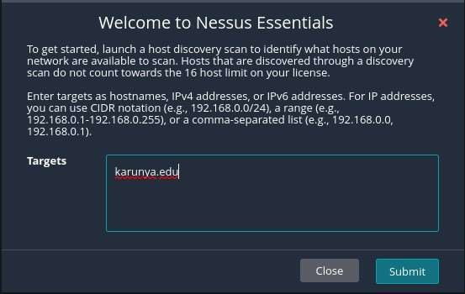**Output:**

**Result:**

The given experiment has been carried out and the output has been verified successfully.